Answers
Task 1
1. (a) Write pseudocode which will read a series of names from a file called names.txt. One name is stored on each line in the file.
OPEN names.txt FOR READ
WHILE NOT EndOfFile DO
READFILE names.txt, name
OUTPUT name
ENDWHILE
CLOSEFILE names.txt
(b) Different programming languages will use different ways to read and write files.
Create a program that will output each name given in names.txt.
Adapt the program so that each name is numbered when it is output – for example:
1 Jane
2 Sam
…
See Python program W2 Task 1 Read names.py for solution to both (a) and (b) – This solution fits closest to the pseudocode used in IGCSE
See Python program W2 Task 1 Read names – method 2.py for a simpler alternative using a FOR loop.
Task 2
1. The following writes to a text file student names and exam results. Each line in the file will have two items of data, name and mark, separated by commas.
OPEN marks.txt FOR WRITE
moreNames True
WHILE moreNames
OUTPUT "Enter student name: "
INPUT name
OUTPUT "Enter student mark: "
INPUT mark
record name + "," + mark
WRITEFILE marks.txt, record
OUTPUT "Enter another student (y/n)? "
INPUT choice
IF choice = "n"
THEN
moreNames False
ENDWHILE
CLOSEFILE marks.txt

(a) In the code, a Boolean variable called moreNames is created. Why is this used?
It determines if there are more names to enter. At the start of the program there will be at least one name to enter so it is first set to True. When the user enters ‘n’, moreNames is changed to False which will cause the while loop to finish.
(b) Create a program that implements the algorithm to enter student names and marks and save them in a file.
marks = open("marks.txt","w") #open the file in write mode
moreNames = True #set the flag
while moreNames: #loop if there are more names
name = input("Enter student name: ")
mark = input("Enter mark: ")
record = name + "," + mark + "\n" #construct the record
marks.write(record) #write the record
choice = input("Enter another student (y/n)? ")
if choice == "n": #if the user has no more students...
moreNames = False #...set the flag to False
marks.close()
See Python program W2 Task 2 Q1 marks file create.py.

2. Write a program that goes through marks.txt to find the top mark stored in the file. The student(s) that achieve the top mark are then output along with the mark.
Test data:
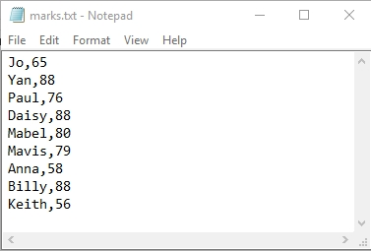
The code in Qu 2 above finds maxMark. The print statement can be removed from this part of the program and then adapted.
The solution given in the Python program shows how this can be done with one pass of the file, storing the highest names in a list.
See Python program W2 Task2 Q2 marks file highest mark with ties.py.
marksFile = open("marks.txt", "r")

moreLines = True
maxMark = 0
students = []
while moreLines:
markRec = marksFile.readline()
if markRec == "":
moreLines = False
else:
field = markRec.split(",")
name = field[0]
mark = int(field[1])
if mark == maxMark:
students.append(name)
elif mark > maxMark:
students = [] #empty the list
students.append(name)
maxMark = mark

marksFile.close()

for i in range(len(students)):
print(students[i], maxMark)

